Ross Bollinger

Dr. M. Owrang

25 April 2019

CSC-434

Theatre Database SQL Code

**Create Database**

Code

create database if not exists Theatre;

use Theatre;

create table if not exists Season

(

play_title varchar(50) not null primary key,

playwright_name varchar(50),

opening_date date,

closing_date date,

theater_name varchar(50) not null

);

create table if not exists Theater

(

name varchar(50) not null primary key,

street varchar(15),

max_seats integer(4)

);

create table if not exists Audience_member

(

ticket_number varchar(12) not null primary key,

confirmation_number varchar(13) not null,

first_name varchar(25),

last_name varchar(25)

);

create table if not exists Ticket

(

ticket_number varchar(12) not null primary key,

seat_number varchar(5),

price integer(3),

seat_section varchar(50),

theater_name varchar(50) not null,

play_title varchar(50) not null

);

create table if not exists Creative_team

(

name varchar(50) not null,

job_title varchar(50),

salary_per_hour integer(5),

play_title varchar(50) not null

);

create table if not exists Cast

(

role varchar(50) not null,

actor_name varchar(50) not null,

play_title varchar(50) not null

);

create table if not exists Actor

(

name varchar(50) not null primary key,

salary_per_hour integer(5),

equity_status varchar(10)

);

create table if not exists Staff

(

ID varchar(7) not null primary key,

first_name varchar(25),

last_name varchar(25),

job_title varchar(50),

salary_per_hour integer(5),

theater_name varchar(50) not null

);

insert into Season values("Guys and Dolls", "Frank Loesser", '2018-08-30', '2018-11-04', "Eisenhower Theater");

insert into Season values("Harvey", "Mary Chase", '2018-10-25', '2018-12-09', "Kreeger Theater");

insert into Season values("Hand to God", "Robert Askins", '2019-01-17', '2019-03-17', "Studio Theater");

insert into Season values("Cat on a Hot Tin Roof", "Tennessee Williams", '2019-05-02', '2019-05-29', "Sidney Harman Hall");

select * from Season;

insert into Theater values("Eisenhower Theater", "F Street", 1161);

insert into Theater values("Kreeger Theater", "Sixth", 514);

insert into Theater values("Studio Theater", "Fourteenth", 200);

insert into Theater values("Sidney Harman Hall", "F Street", 774);

select * from Theater;

insert into Audience_member values("T65532926857", "11I1AYJNWDMXL", "Tyson", "Bristol");

insert into Audience_member values("T12194953219", "K82ATILX5JEPI", "Bettie", "Mann");

insert into Audience_member values("T53466048953", "HDV7QRFTNXU0A", "Kimmie", "Burnham");

insert into Audience_member values("T52583813549", "V9YXB5GLG3706", "Jordana", "York");

insert into Audience_member values("T60301255854", "2OQ1RC6UOLT00", "Allana", "Brook");

insert into Audience_member values("T42925458325", "W5KJEBIJQGDEB", "Judi", "Larson");

insert into Audience_member values("T11878498645", "K0ULD7N2C1RCM", "John", "Groves");

select * from Audience_member;

insert into Ticket values("T65532926857", "G107", 102, "Orchestra", "Kreeger Theater", "Harvey");

insert into Ticket values("T60596108598", "H101", 179, "Orchestra", "Eisenhower Theater", "Guys and Dolls");

insert into Ticket values("T12194953219", "R110", 92, "Orchestra Grand Tier", "Sidney Harman Hall", "Cat on a Hot Tin Roof");

insert into Ticket values("T53466048953", "A13", 109, "Balcony", "Eisenhower Theater", "Guys and Dolls");

insert into Ticket values("T52583813549", "M20", 179, "Orchestra", "Eisenhower Theater", "Guys and Dolls");

insert into Ticket values("T45050502323", "AA202", 45, "Premium", "Studio Theater", "Hand to God");

insert into Ticket values("T60301255854", "C104", 20, "Zone A", "Studio Theater", "Hand to God");

insert into Ticket values("T42925458325", "AA12", 102, "Balcony", "Kreeger Theater", "Harvey");

insert into Ticket values("T11878498645", "D121", 92, "Orchestra Front", "Sidney Harman Hall", "Cat on a Hot Tin Roof");

select * from Ticket;

insert into Creative_team values("Holly Stevens", "Director", 30, "Hand to God");

insert into Creative_team values("Mel Caulfield", "Costume Designer", 20, "Guys and Dolls");

insert into Creative_team values("Peter Blakeley", "Director", 50, "Cat on a Hot Tin Roof");

insert into Creative_team values("Caleigh Glass", "Lighting Designer", 46, "Guys and Dolls");

insert into Creative_team values("Milo Sanders", "Set Designer", 25, "Harvey");

select * from Creative_team;

insert into Cast values("Nathan", "Alex Brightman", "Guys and Dolls");

insert into Cast values("Sky", "Armie Hammer", "Guys and Dolls");

insert into Cast values("Elwood", "Paul Schneider", "Harvey");

insert into Cast values("Veta", "Janet McTeer", "Harvey");

insert into Cast values("Jason", "Steven Boyer", "Hand to God");

insert into Cast values("Margery", "Geneva Carr", "Hand to God");

insert into Cast values("Brick", "Jack O'Connell", "Cat on a Hot Tin Roof");

insert into Cast values("Maggie", "Sienna Miller", "Cat on a Hot Tin Roof");

select * from Cast;

insert into Actor values("Alex Brightman", 42, "equity");

insert into Actor values("Armie Hammer", 42, "equity");

insert into Actor values("Paul Schneider", 35, "nonequity");

insert into Actor values("Janet McTeer", 35, "nonequity");

insert into Actor values("Steven Boyer", 35, "equity");

insert into Actor values("Geneva Carr", 35, "nonequity");

insert into Actor values("Jack O'Connell", 37, "equity");

insert into Actor values("Sienna Miller", 37, "nonequity");

select * from Actor;

insert into Staff values("4874979", "John", "Starr", "Set Builder", 30, "Eisenhower Theater");

insert into Staff values("1600277", "Peter", "Mikhail", "Set Painter", 30, "Kreeger Theater");

insert into Staff values("3016914", "Alex", "Damman", "Master Electrician", 60, "Eisenhower Theater");

insert into Staff values("5881833", "Erin", "Sullivan", "Lighting Coordinator", 45, "Studio Theater");

insert into Staff values("9784995", "Jack", "Johnson", "Set Builder", 33, "Sidney Harman Hall");

insert into Staff values("4397949", "Zack", "Jordan", "Usher", 9, "Studio Theater");

insert into Staff values("6784866", "Edward", "Hope", "Lighting Coordinator", 50, "Sidney Harman Hall");

insert into Staff values("1201393", "Randy", "Howenstein", "Assistant Electrician", 46, "Kreeger Theater");

select * from Staff;

Output

Season:

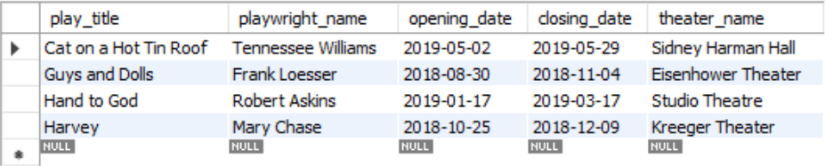

Theater:

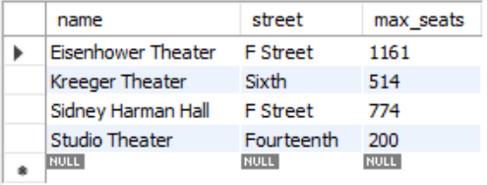

Audience_member:

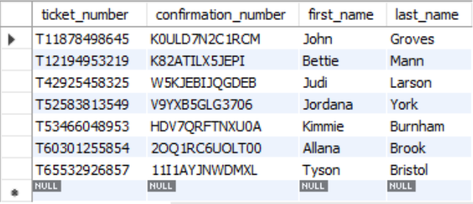

Ticket:

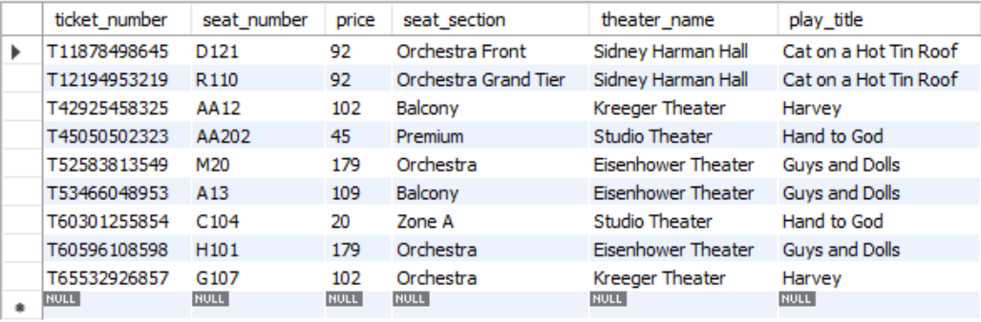

Creative_team:

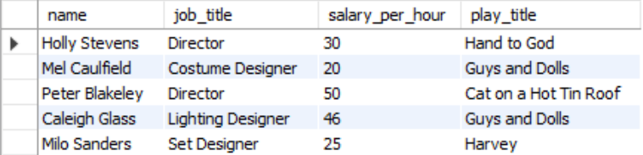

Cast:

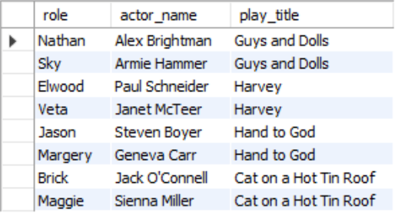

Actor:

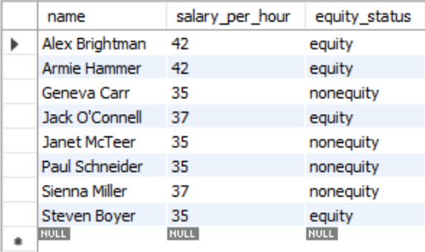

Staff:

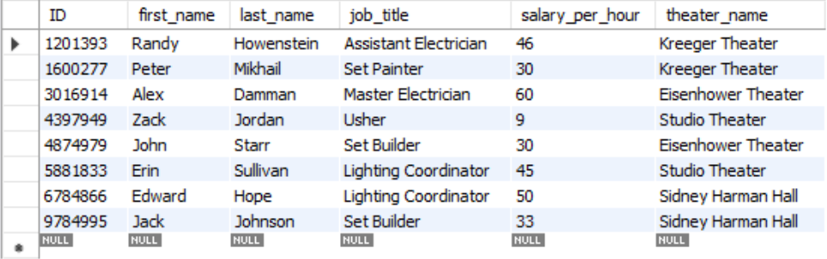

1. **Queries**

* **SELECT:**
* select involving one/more conditions in Where Clause
* Select all ticket numbers where price is greater than or equal to $100 and the seat section says "Orchestra".
  + Code:   
    select ticket_number from Ticket   
    where price >= 100   
    and seat_section like '%Orchestra%';
  + Output:  
    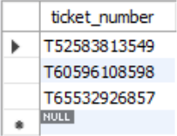
* select with aggregate functions (i.e., SUM,MIN,MAX,AVG,COUNT)
* SUM and Nested SELECT
* Find the sum of all hourly salaries for all Actors working at the Kreeger Theater.
  + Code:

select sum(salary_per_hour) from Actor

where name in

(select actor_name from Cast where play_title in

(select play_title from Season

where theater_name = 'Kreeger Theater'));

* + Output:  
    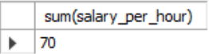
* MIN
* Find the job title, theater name, and salary of the staff job with the lowest hourly pay.
  + Code:

select job_title, theater_name, min(salary_per_hour) from Staff;

* + Output:  
    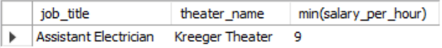
* MAX
* Find the full name of the audience member, price, and seat section of the most expensive ticket purchase for any of the productions in the season.
  + Code:

select first_name, last_name, max(price), seat_section from Audience_member, Ticket;

* + Output:  
    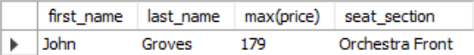
* AVG
* Find the average price of a ticket at the Eisenhower Theater.
  + Code:

select avg(price) from Ticket

where theater_name = 'Eisenhower Theater';

* + Output:  
    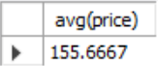
* COUNT and GROUP BY
* Find the number of tickets purchase per production. Display count, play title, and theater name.
  + Code:

select count(ticket_number), play_title, theater_name from Ticket

group by play_title;

* + Output:  
    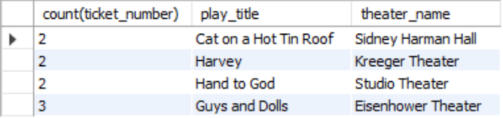
* Select with Having, Group By (already completed), Order By clause
* HAVING
* Find the jobs, theater names, and salaries associated with staff members with salaries below $40/hr.
  + Code:

select job_title, theater_name, salary_per_hour from Staff

having salary_per_hour < 40;

* + Output:  
    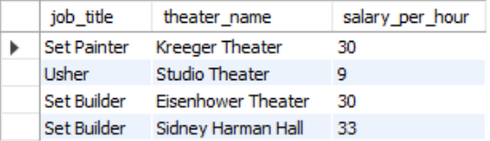
* ORDER BY
* Find the titles of plays grouped by the max seats of the theaters at which they are performed.
  + Code:

select play_title, max_seats from Season, Theater

where Season.theater_name = Theater.name

order by max_seats;

* + Output:  
    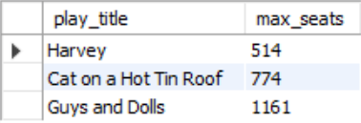
* Select involving the Union operation
* Find all ticket numbers recorded with audience members. Not all ticket numbers are recorded into the audience_member table, so this is a way to double check if all tickets are logged.
  + Code:

select ticket_number from Audience_member

union

select ticket_number from Ticket;

* + Output:  
    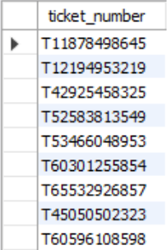
* **INSERT:**
* Insert one tuple into a table
* Alex Brightman will also be playing the role of Wilson in Harvey, add him to that cast list.
  + Code:

insert into Cast values("Wilson", "Alex Brightman", "Harvey");

select * from Cast

where play_title = 'Harvey';

* + Output:  
    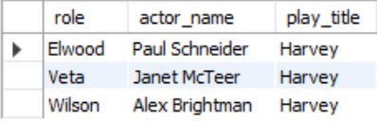
* Insert a set of tuples (by using another select statement)/insert involving two tables
* Create a separate table and fill it with only the info about equity actors who are in

the musical Guys and Dolls. Fill specifically with the equity status and name of the actor.

* + Code:

create table if not exists G_and_D_Equity(

actor_name varchar(50) not null primary key,

equity_status varchar(10)

);

insert into G_and_D_Equity

select name, equity_status from Actor

where equity_status = 'equity'

and name in

(select actor_name from Cast where play_title = 'Guys and Dolls');

select * from G_and_D_Equity;

* + Output:  
    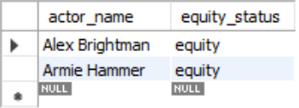
* **DELETE:**
* Delete one tuple or a set of tuples: from one table, from multiple tables
* Delete all tickets that cost above $100.
  + Code:

delete from Ticket

where price > 100;

select * from Ticket;

* + Output:  
    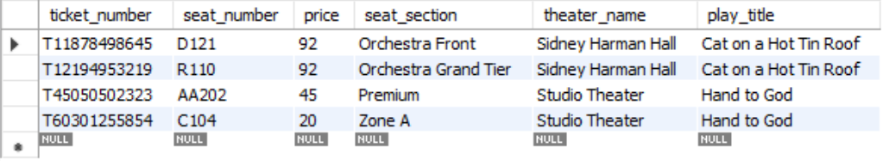
* **UPDATE:**
* Update one tuple or a set of tuples: from one table, from multiple tables
* Add a bonus of 5% to actors with salaries below $40/hr.
  + Code:

select * from Actor;

update Actor

set salary_per_hour = (salary_per_hour * .05) + salary_per_hour

where salary_per_hour < 40;

select * from Actor;

* + Output:  
    Before:  
    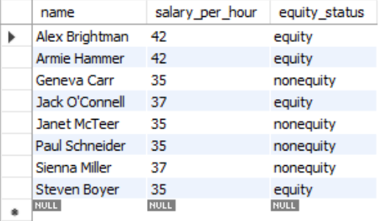  
    After:  
    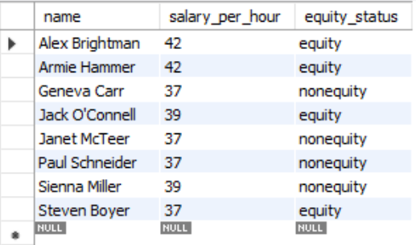
* **CREATE VIEW:**
* Create a view of all ticket info with audience member names.
  + Code:

create view allTicketInfo

as select Audience_member.ticket_number, confirmation_number, first_name, last_name, seat_number, price, seat_section, theater_name, play_title

from Audience_member, Ticket

where Audience_member.ticket_number = Ticket.ticket_number;

select * from allTicketInfo;

* + Output:  
    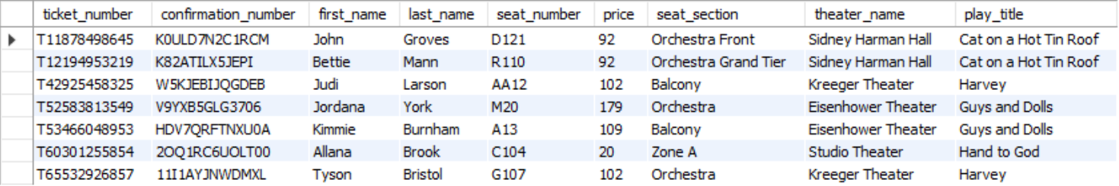
* Create a new view of just employee IDs and job titles from staff.
  + Code:

create view simpleStaff

as select ID, job_title, theater_name from Staff;

select * from simpleStaff;

* + Output:  
    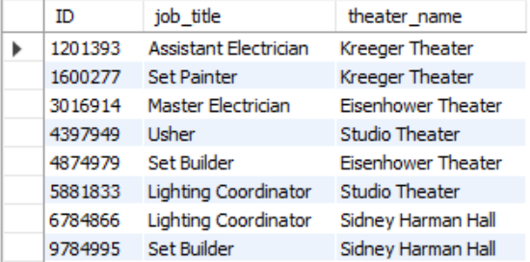
* Operate on View
* SELECT
* Find the names of all audience members who paid under $100 for a ticket.
  + Code:

select first_name, last_name, price from allTicketInfo

where price < 100;

* + Output:  
    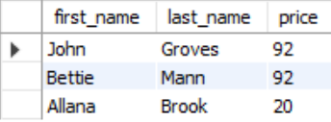
* INSERT
* Insert a new item into the Employee view.
  + Code:

insert into simpleStaff values ("2587213", "Set Painter", "Sydney Harman Hall");

select * from simpleStaff;

* + Output:  
    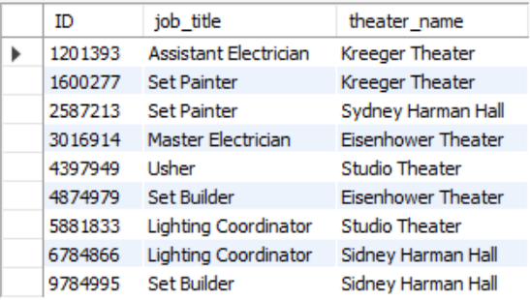
* DELETE
* Delete all staff info of workers at Kreeger Theater using the Staff View.
  + Code:

delete from simpleStaff

where theater_name = 'Kreeger Theater';

select * from simpleStaff;

* + Output:  
    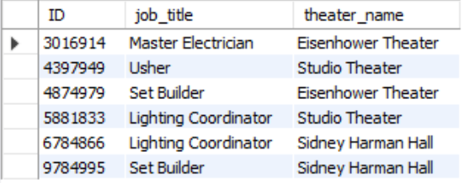
* UPDATE
* All employees at the Studio Theater are getting laid off. They moved to the Eisenhower Theater.
  + Code:

select * from simpleStaff;

update simpleStaff

set theater_name = 'Eisenhower Theater'

where theater_name = 'Studio Theater';

select * from simpleStaff;

* + Output:  
    Before:  
    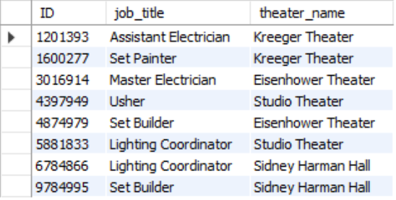  
    After:  
    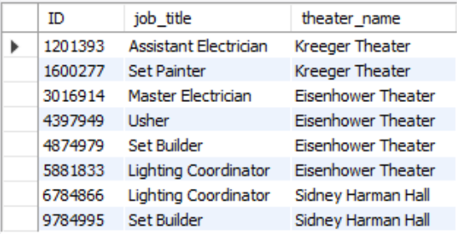

1. **Triggers**

* Enforcing referential integrity
* Create a trigger that ensures that no duplicate entries will be inserted or updated on Cast.
  + Code:

delimiter $$

create trigger no_Cast_Duplicates

before insert on Cast

for each row

begin

if (exists(select 1 from Cast where role = new.role

and actor_name = new.actor_name

and play_title = new.play_title))

then signal sqlstate value '45000' set message_text = 'INSERT failed due to duplicate entry';

end if;

end$$

delimiter ;

insert into Cast values("Elwood", "Paul Schneider", "Harvey");

* + Output:  
    
* Enforcing attribute domain constraints
* Create 3 triggers that all ensure that all inserts on Ticket, Audience_member, and Staff follow the number of digits per key.
  + Code:

delimiter $$

create trigger ticket_Num_Limit

before insert on Ticket

for each row

begin

if (exists(select 1 from Ticket where length(ticket_number) <>  
 length(new.ticket_number)))

then signal sqlstate value '45000' set message_text = 'INSERT failed due to incorrect length of ticket number';

end if;

end$$

delimiter ;

insert into Ticket values("T655329268", "G107", 102, "Orchestra", "Kreeger Theater", "Harvey");

delimiter $$

create trigger aud_Num_Limit

before insert on Audience_member

for each row

begin

if (exists(select 1 from Audience_member where length(ticket_number)<> length(new.ticket_number)))

then signal sqlstate value '45000' set message_text = 'INSERT failed due to incorrect length of ticket number';

end if;

end$$

delimiter ;

insert into Audience_member values("T655329268", "11I1AYJNWDMXL", "Tyson", "Bristol");

delimiter $$

create trigger staff_Num_Limit

before insert on Staff

for each row

begin

if (exists(select 1 from Staff where length(ID) <> length(new.ID)))

then signal sqlstate value '45000' set message_text =  
'INSERT failed due to incorrect length of ID number';

end if;

end$$

delimiter ;

insert into Staff values("678486", "Edward", "Hope", "Lighting Coordinator", 50, "Sidney Harman Hall");

* + Output:  
    Ticket:  
      
    Audience_member:  
      
    Staff:  
    
* Creating a database log
* Create a trigger that keeps track of which seats (number, section, and theater) are filled in each theater on insert into ticket.
  + Code:

delimiter $$

create trigger seat_Logger

after insert on Ticket

for each row

begin

insert into seat_Log values(new.seat_number, new.seat_section, new.theater_name);

end$$;

delimiter ;

select * from Seat_log;

* + Output:  
    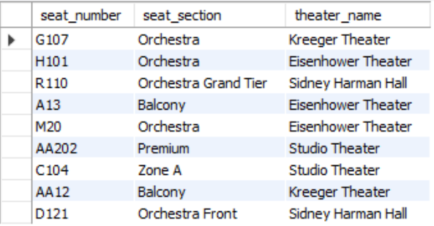
* Gathering statistics
* Create a trigger that keeps track of the average staff member salary after insert into Staff.
  + Code:

create table if not exists Staff_sal_avg (theater_name varchar(50), avg_salary integer(4));

insert into Staff_sal_avg values("Eisenhower Theater", 0);

insert into Staff_sal_avg values("Kreeger Theater", 0);

insert into Staff_sal_avg values("Studio Theater", 0);

insert into Staff_sal_avg values("Sidney Harman Hall", 0);

delimiter $$

create Trigger salary_Averager

after insert on Staff

for each row

begin

update Staff_sal_avg

set avg_salary = (select avg(salary_per_hour) from Staff

where Staff.theater_name = new.theater_name)

where theater_name = new.theater_name;

end$$

delimiter ;

select * from Staff_sal_avg;

* + Output:  
    